Assignment 3 – distributed systems

Vaida Diana-Laura, group 3

Conceptual architecture of the distributed system

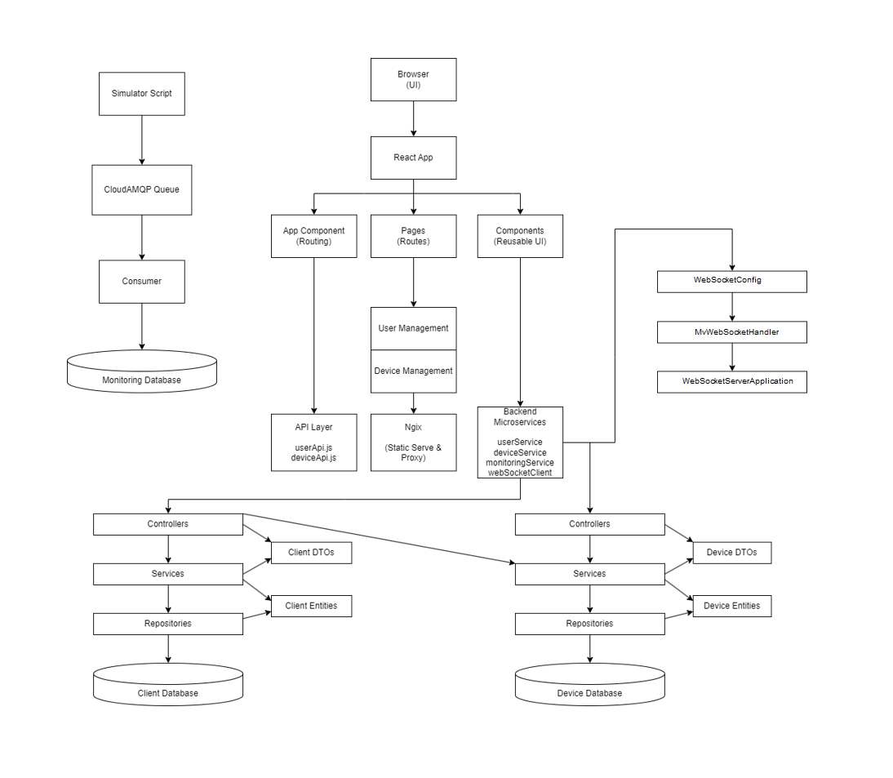

UML Deployment diagram

All the functionalities from before work the same for the admin and user role.

Having the role of the admin you can perfom CRUD on users and devices, and map a device to a user.

If you try to enter a page without having the required role or not signed in, you will be redirected to the home page.

Having the role of user means you are redirected to a chat that is using a websocket, and you can also chat with others users who are connected to the chat. Also 2 buttons for logout and devices assigned to that user are present.